***Assignment 4:***

Arjun Patel - FRN006

Q1) Print Armstrong number in range 1 to n

*#include* <stdio.h>

*#include* <math.h>

*// if 123 is num, and 1^3 + 2^3 + 3^3 = 123, then its armstrong num*

*// example 153 = 1 + 125+ 27 is armstrong num*

*// 1634 = 1^4 + 6^4 + 3^4 + 4^4*

int findPower(int base, int exponent)

{

    int power *=* 1;

*while* (exponent*--*)

    {

        power *\*=* base;

    }

*return* power;

}

int main()

{

    int num;

    printf("Enter a number upto which u want to armstrong nums:\n");

    scanf("%d", *&*num);

*for* (int i *=* 1; i *<=* num; i*++*)

    {

        int temp *=* i, sum *=* 0, count *=* 0;

*// find length of number to find exponent*

*while* (temp *>* 0)

        {

            count*++*;

            temp */=* 10;

        }

*// temp becomes 0, so ressign for further use*

        temp *=* i;

*while* (temp *>* 0)

        {

            int rem *=* temp *%* 10;

*// cal power of rem*

            int power *=* 1, exponent *=* count;

            sum *+=* findPower(rem, exponent);

            temp */=* 10;

        }

        sum *==* i *&&* printf("%d ", i);

    }

*return* 0;

}

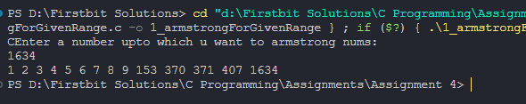

Q2) Check Prime number in Range

*#include* <stdio.h>

void checkPrime(int num)

{

    int isPrime;

*for* (int i *=* 2; i *\** i *<=* num; i*++*)

    {

        isPrime *=* 1;

*if* (num *%* i *==* 0)

        {

            isPrime *=* 0;

*break*;

        }

    }

*if* (isPrime)

    {

        printf("%d ", num);

    }

}

int main()

{

    int num, isPrime *=* 1;

    printf("Enter number upto which u want to check prime of\n");

    scanf("%d", *&*num);

*for* (int i *=* 1; i *<=* num; i*++*)

    {

        checkPrime(i);

    }

*return* 0;

}

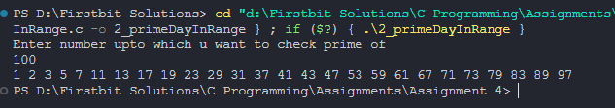

Q3) Check Perfect num in range

*#include* <stdio.h>

*// number can be called perfect if, sum of its divisors is same as number itself*

*// ex: 6 because 1 + 2 + 3 = 6*

*// 28 beacuse, 1 +2 + 4 + 7 + 14 =28*

void checkPerfect(int num)

{

    int sum *=* 0;

*for* (int i *=* 1; i *<=* num*/*2; i*++*)

    {

*if*(num*%*i*==*0) sum *+=* i;

    }

*if* (num *==* sum)

        printf("%d ", num);

}

int main()

{

    int num;

    printf("Upto which range u want to check perfect num: ");

    scanf("%d", *&*num);

*for* (int i *=* 1; i *<=* num; i*++*)

    {

        checkPerfect(i);

    }

*return* 0;

}

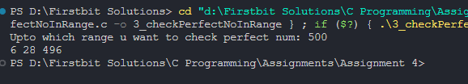

Q4) Check Strong number in range 1 to n

*#include*<stdio.h>

*//num is called strong if its sum of its digit's factorial is same as num*

*//ex: 145, 1! + 4!+ 5! = 145*

void checkStrong(int num){

    int temp *=* num, rem, sum*=*0;

*while*(temp*>*0){

        rem *=* temp*%*10;

*//--------Factorial Part-------*

*//find factorial of rem*

        int factorial*=*1;

*while*(rem*>*0){

            factorial *\*=* rem;

            rem*--*;

        }

*//add factorial of rem to sum*

        sum *+=* factorial;

*//continue*

        temp */=* 10;

    }

*if*(sum*==*num) printf("%d ", num);

}

int main(){

    int num;

    printf("Enter a number:\n");

    scanf("%d", *&*num);

*for* (int i *=* 1; i *<=* num; i*++*)

    {

        checkStrong(i);

    }

*return* 0;

}

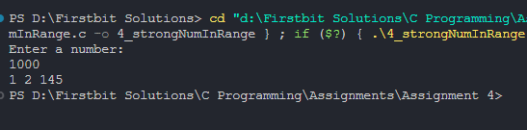

Q5) Print Fibonacci upto n number

*#include*<stdio.h>

*//0 1 1 2 3 5 8 13 21 34 55*

int main(){

    int num, first *=*0, second *=* 1, next *=* 0;

    printf("Enter a number\n");

    scanf("%d", *&*num);

*while* (next*<=*num)

    {

        printf("%d ", next);

        first *=* second;

        second *=* next;

        next *=* first *+* second;

    }

*return* 0;

}

